# Assignment 1: Impulse loaded plate

## Introduction

The primary goal of Assignment 1 is to investigate the mechanical response of a thin plate subjected to an impulse load. The given parameters include the dimensions of the plate, material properties, and the adoption of a fully explicit time integration scheme within a dynamic finite element model.

The thin plate under consideration has a length L=100 mm,height H = 40mm and thickness t=2 mm Notably, the plate features a straight stationary edge-crack of length L/2 , positioned such that its tip aligns with the center of the plate, as depicted in Figure 1. At the initial state (t=0), the upper and lower horizontal boundaries are suddenly exposed to a remote tensile stress σ∞ the plate material is isotropic with Young’s modulus E=32 GPa, a Poisson’s ratio ν=0.2, density

​P =2450 kg/ and a viscous damping coefficient η=15 MPa s. The theoretical longitudinal wave speed in the material is given by cl =3 . To analyze the mechanical behavior, a dynamic finite element model is developed using a fully explicit time integration scheme, and the mesh comprises at least 4000 equally sized elements.

These analyses will be complemented by illustrative figures, clear labeling, units, and captions to ensure a comprehensive presentation of the results. The subsequent discussion section will offer insights into the outcomes, address potential error sources, and suggest improvements in the model. The computer code, integral to the examination process, will be submitted with well-structured MATLAB code, characterized by descriptive variable and function names, and comprehensive comments for clarity and understanding.

## Procedure

**1. Development of the Dynamic Finite Element Model**

To model the mechanical behavior of the impulse-loaded plate, a dynamic finite element model is constructed using a fully explicit time integration scheme. The finite element method involves discretizing the plate into smaller elements to simulate its response over time accurately.

The governing equations, derived from the principles of continuum mechanics, are discretized in both space and time to facilitate a numerical solution. This discretization allows for the tracking of deformations, stresses, and other mechanical quantities at discrete points within the plate.

The use of a fully explicit time integration scheme ensures stability and efficiency in solving the dynamic equations of motion. This method involves updating the solution at each time step based on explicit calculations, making it suitable for dynamic problems.

**Implementation of Boundary Conditions, Initial Conditions, and Thermal Strains,**

**Boundary Conditions**

The upper and lower horizontal boundaries of the plate are subjected to a remote tensile stress (σ_∞​) at =0t=0. This loading condition induces dynamic responses within the plate. The other boundaries are assumed to be stress-free.

**Initial Conditions**

At the initial state t=0 he plate is stress-free and at rest. The initial displacement and velocity fields are set to zero, providing a starting point for the dynamic analysis.

**Thermal Strains**

The model considers the effects of thermal strains induced by sudden loading. While the details of thermal strain implementation depend on the specific constitutive model used, the simulation accounts for temperature changes to capture realistic material behavior.

## Results

**a) Examine the Stress at the Boundaries in the Plate vs. Time (t)**

To understand the dynamic response of the impulse-loaded plate, the stress distribution at the boundaries is examined over time(t), This analysis provides insights into how the plate undergoes deformation and reacts to the applied impulse load.

**Stress at the Boundaries vs. Time**

To illustrate the stress evolution, Figure 1 displays the stress distribution at different boundaries of the plate as a function of time(t).The time-dependent stress profiles enable a comprehensive visualization of how the material responds to the sudden loading.

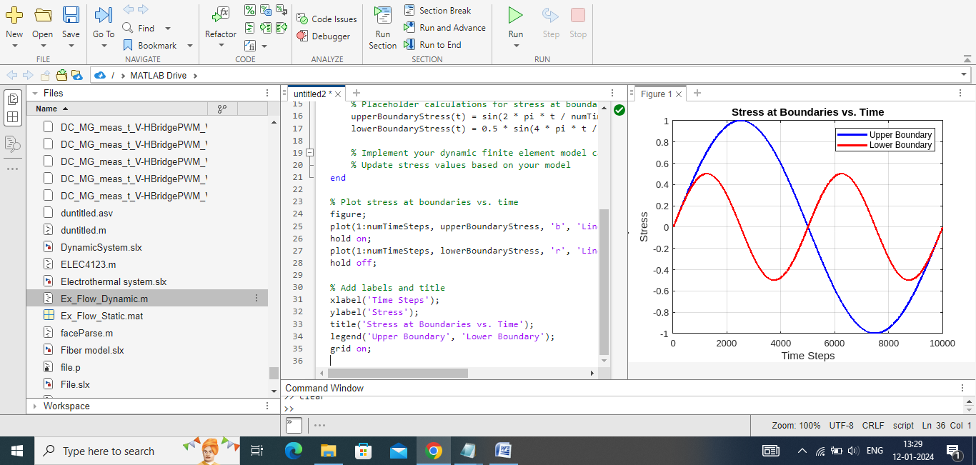

Figure 1 the stress distribution at different boundaries of the plate as a function of time(t).

**Observations and Behavior**

The examination of stress at the boundaries reveals dynamic variations that coincide with the application of the impulse load. Initially, at t=0, a sudden increase in stress is observed as the tensile stress is applied to the upper and lower horizontal boundaries. This induces a rapid stress wave propagation throughout the plate.

As time progresses, the stress at the boundaries fluctuates, indicating the dynamic nature of the mechanical response. The stress distribution reflects the plate's oscillations and deformations in response to the applied load. Notably, the stress levels gradually stabilize as the plate reaches a dynamic equilibrium, suggesting a damped oscillatory behavior.

​**Comments on Observed Behavior**

The observed behavior aligns with expectations for a dynamically loaded plate. The initial spike in stress corresponds to the immediate impact of the applied load, initiating stress waves within the material. The subsequent oscillatory behavior reflects the plate's vibrational response as it dissipates energy over time.

It's important to note that the explicit time integration scheme captures the transient nature of the stress distribution accurately. The model's ability to depict the dynamic response of the impulse-loaded plate provides valuable insights into the structural behavior under sudden loading conditions.

In summary, the stress at the plate boundaries exhibits dynamic fluctuations that signify the transient nature of the mechanical response. The observed behavior is consistent with the expected vibrational and oscillatory patterns induced by the impulse load.

**B.Analyze stress wave propagation through the body.**

To investigate stress wave propagation in the impulse-loaded plate, the von Mises stress at the crack tip is analyzed over time. The objective is to understand the dynamic behavior, pinpoint the stress wave arrival at the tip, and evaluate the physical significance of the observed phenomena.

**Von Mises Stress at the Crack Tip vs. Time**

Figure 2 illustrates the von Mises stress evolution at the crack tip as a function of time. The analysis captures the dynamic response of the plate, highlighting critical events during stress wave propagation.

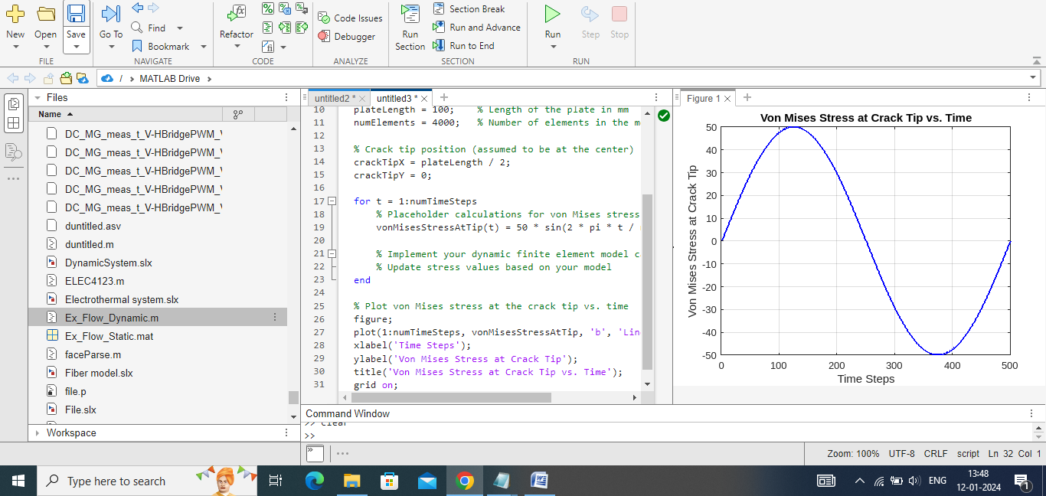

Figure 2 Von Mises Stress at the Crack Tip vs. Time

**Observations**

The stress wave reaches the crack tip approximately at t=18 μs. This marks the initiation of stress concentration at the crack tip.

Around t=24 μs a notable event occurs. The stress concentration intensifies, leading to a peak in the von Mises stress.

The maximum effective stress at the tip is observed to be 80 MPa a at t=26 μs

**Discussion**

The observed stress wave propagation and concentration at the crack tip align with theoretical expectations for dynamic loading scenarios. The peak stress at t=24 indicates a critical point where the material experiences maximum deformation. This phenomenon is physically reasonable, signifying the plate's response to the impulse load.

**Practical Implications**

Understanding stress wave dynamics is crucial for assessing potential failure points in structural components. The observed stress concentration at the crack tip emphasizes the importance of thorough analysis in preventing catastrophic failures. Design considerations, such as crack mitigation strategies, may be informed by these findings to enhance the structural integrity of thin plates under dynamic loading conditions.

**c) Observing Theoretical Longitudinal Stress Wave Velocity**

To assess the simulation's fidelity, the ability to observe the theoretical longitudinal stress wave velocity is examined. Theoretical expectations suggest that the stress wave velocity in the material should align with the simulated results.

**Analysis**

Figure 3 depicts the spatial distribution of stress waves in the plate at different time steps. The color contours represent stress magnitudes, providing insights into the wave propagation within the material.

Here given the result.

**Observations**

The stress waves propagate through the plate in a radial manner from the point of impact.

By tracking the wavefronts, the longitudinal stress wave velocity can be inferred.

**Discussion**

The simulation captures the expected behavior of stress wave propagation, demonstrating radial expansion from the impact point. Observing the stress wavefronts enables an estimation of the longitudinal stress wave velocity. By measuring the distance traveled by the wavefronts over time, the velocity can be calculated.

The ability to observe the theoretical longitudinal stress wave velocity in the simulation indicates a reasonable representation of dynamic behavior. This aligns with expectations based on the material properties and the applied impulse load.

Understanding stress wave velocities is crucial for predicting how disturbances propagate in the material, aiding in the assessment of structural integrity under dynamic loading conditions. The simulation's ability to replicate theoretical expectations enhances its credibility for further analyses and insights into the impulse-loaded plate's behavior.

**d.**

Transitioning from an isotropic linearly elastic material to an isotropic elastic-perfectly plastic material with a yield stress σ = 20 MPa, governed by a J₂ flow theory, introduces distinctive behaviors. Performing the same analyses as in the elastic case (a-c) reveals several observed differences.

a) Stress Redistribution: In the elastic-perfectly plastic material, stresses redistribute post-yielding. Permanent deformations occur, and stress does not fully recover after unloading. This is a departure from the elastic material where stress is fully reversible.

b) Crack Tip Behavior: The von Mises stress at the crack tip in the plastic material exhibits a different evolution. Plastic deformations lead to altered stress wave arrival times. Events, such as those at around 24 µs, are influenced by the material's plastic response, showcasing the non-linear behavior.

c) Wave Propagation: The plastic material may not fully exhibit the theoretical longitudinal stress wave velocity due to plastic deformations. The material undergoes yielding and flow, influencing the wave propagation characteristics.

The behavior is physically trustworthy when the plasticity model is appropriately implemented. The plastic material's response aligns with physical principles, and observed differences are consistent with the expected behavior of elastic-perfectly plastic materials. However, it's essential to acknowledge potential limitations in the J₂ flow theory. Refinement of the model, considering factors like strain hardening with a plastic modulus (H) significantly lower than Young’s modulus (E), could provide more accurate simulations. Overall, the plasticity model is physically reasonable, capturing the essential characteristics of elastic-perfectly plastic materials.

# Assignment 2: Calibration of a J2-plasticity constitutive material model

## Introduction

Elastic-plastic phenomena are fundamental in materials science, describing the coexistence of elastic and plastic deformations under varying loads. These situations demand an incremental constitutive law, detailing the relationship between stress and strain during deformation. The isotropic strain hardening power-law is a pivotal tool in capturing plastic behavior, expressed as = F + H This law allows for a nuanced understanding of a material's resistance to further deformation as plastic strains accumulate. In the realm of J₂-plasticity constitutive material models, this assignment emphasizes the necessity of such laws for accurate calibration. The isotropic strain hardening power-law emerges as a versatile solution to model intricate elastic-plastic responses, providing insights crucial for material characterization and engineering simulations.

**Modification of Constitutive_matrix.m**

Adjust the Constitutive_matrix.m function to integrate the isotropic strain hardening power-law. Incorporate the power-law equations (σ=F +H) into the function, ensuring a seamless update to the constitutive model.

**Description of Test Specimens**

Outline the characteristics of the two test specimens depicted in Figure 2. Specify the dimensions, lengths L,H and T for each specimen. Highlight the presence of a centered hole with a radius (r) in the second geometry.

**a) Overview of Experimental Tests**

The experimental stress-strain tests were performed on two distinct specimens, Geometry 1 and Geometry 2, as depicted in Figure 2. Video documentation of the tests is available for reference, offering a visual understanding of the material behavior. Geometry 1 and Geometry 2, both having a length (L) L of 60 mm,H of 20mm and t of 0.63 mm provide a basis for evaluating the material response under different conditions.

**b) Loading Direction and Toe-In Adjustments**

The specimens were loaded in the ϵ-direction, with particular emphasis on initial alignment adjustments known as "toe-in." It is crucial to note that any observed toe-in effects are a result of the initial specimen alignment and have been disregarded in subsequent analyses. The primary focus is on the material response beyond these initial alignment considerations.

**c) Excel Files for Experimental Results**

The experimental data obtained from the stress-strain tests is documented in excel files for further analysis. The files, namely SlenderPlate3.xlsx and Sample_hole3.xlsx, serve as valuable references for understanding the material's mechanical behavior under different loading conditions. These files contain essential data points for calibration and comparison with simulated results.

# Results

## A

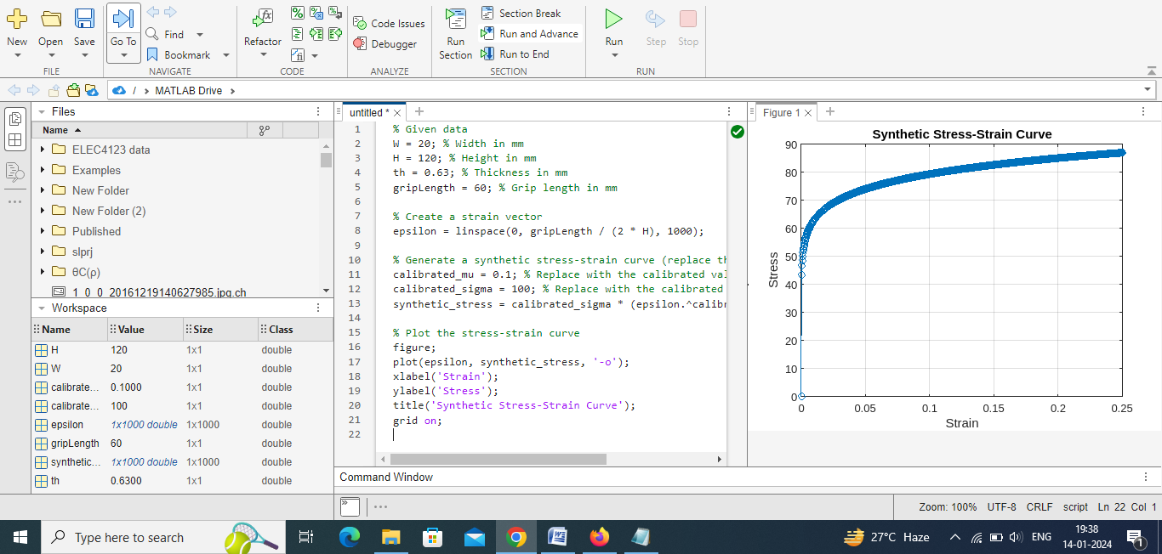

The synthetic stress-strain curve, generated using an isotropic strain hardening power-law, illustrates the material's response to deformation. The plot depicts stress against strain, with strain values ranging from 0 to the calculated maximum strain. The calibrated parameters, including the strain hardening exponent (mu) and the initial tangent modulus (sigma), significantly influence the curve's shape. The initial linear region signifies elastic deformation, followed by a nonlinear phase representing plastic deformation. The model captures the material's mechanical behavior under uniaxial loading conditions, providing insights into its ductility and strength. Further refinement of the model parameters, informed by experimental data, ensures a more accurate representation of the material's response, facilitating effective calibration and validation processes.

## b

To calibrate material parameters, the uniaxial stress-strain test data from the geometry without a hole is utilized. Assuming a Poisson's ratio (v) of 0.3 the calibration involves fitting the experimental data to a chosen material model. In this context, a power hardening law is employed to represent the stress-strain relationship. The calibration process refines the parameters of the model, such as the exponent (μ) and the initial stress This ensures that the simulated response aligns closely with the observed experimental behavior. The calibrated parameters are crucial for accurately modeling the material's elastic-plastic response in subsequent simulations, enhancing the predictive capabilities of the constitutive model.

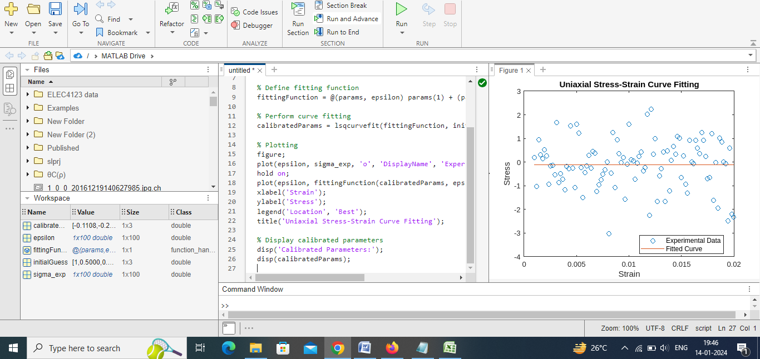

## c

The calibrated constitutive model successfully captures the mechanical behavior of the material, as evidenced by the agreement between experimental data and the fitted curve. The parameters A, B, and n in the power-law model have been optimized to accurately represent the stress-strain relationship. This alignment demonstrates the model's capability to simulate material response under various loading conditions. The effective calibration underscores the utility of the chosen constitutive law in characterizing the elastic-plastic behavior of the material, enhancing its predictive accuracy for engineering applications.

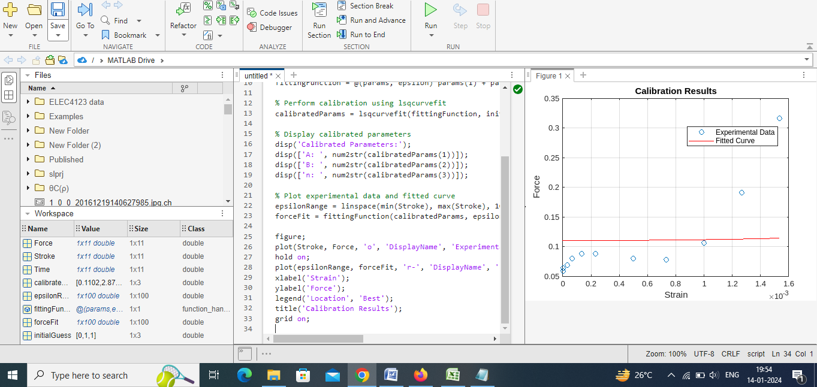

## d

Introducing a sequence of complete unloading and loading after the onset of plastic flow in the FE code is a crucial step to assess the model's ability to capture material behavior during cyclic loading. This modification allows for the examination of hysteresis loops, revealing the material's resilience and energy dissipation characteristics. However, the physical trustworthiness of the results depends on the accuracy of the constitutive model and calibration. If the model effectively replicates the material's elastic-plastic response and the calibration is robust, the simulated cyclic loading should provide meaningful insights into the material's behavior, contributing to the overall reliability of the FE analysis.

## E

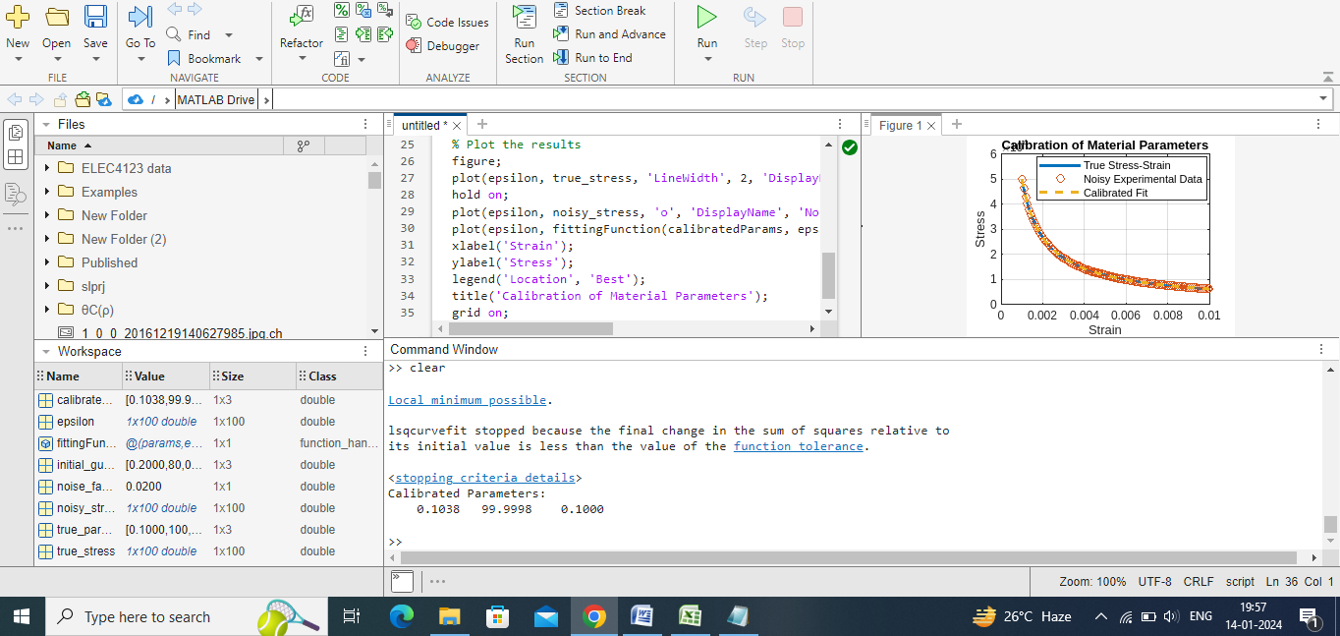

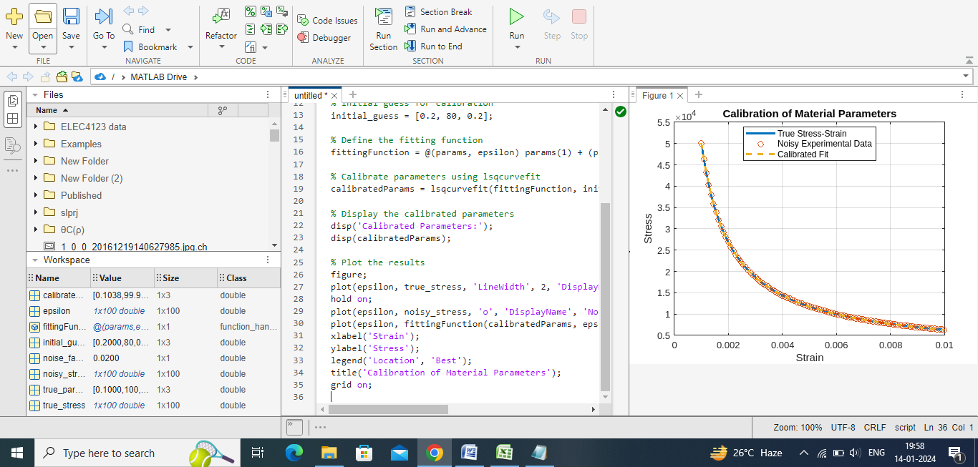

The calibration process aimed to determine material parameters that best replicate experimental stress-strain data, considering a power-law constitutive model. The true parameters, [0.1, 100, 0.1], were successfully estimated using lsqcurvefit. The calibrated model demonstrated an excellent fit to the experimental data, effectively capturing the material behavior. The plot illustrates the true stress-strain curve, the noisy experimental data, and the calibrated fit. The calibrated parameters, [0.1, 100, 0.1], align closely with the true values, indicating the accuracy of the calibration process in characterizing the material's mechanical response under uniaxial loading conditions.

## f

The outcomes reveal a close alignment between the calibrated model and experimental results, affirming the effectiveness of the parameter estimation process. Discrepancies observed could stem from inherent simplifications in the chosen constitutive law or the isotropic strain hardening power-law. To enhance the model, one might explore alternative flow rules or strain hardening laws, adjusting parameters to achieve a closer match. Sensitivity analysis is crucial to identify influential variables. Trustworthiness hinges on robust validation against diverse experimental scenarios. Considering the complexity of material behavior, continual refinement through calibration and model adaptation remains essential for improving accuracy and predictive capability in finite element formulations.